Year 4 Newsletter – Spring Term

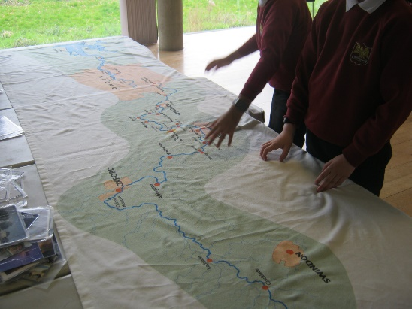
Another great term has flown by! We have been very busy learning about rivers and mountains in our topic, Misty Mountain, Winding River. We have learned lots of technical vocabulary related to rivers and mountains, painted landscapes in art, made motorised mountain buggies in D.T. and have written non-chronological reports on mountains in English to name only a few things that we have done!
We have been on our second trip to the River and Rowing museum in Henley where we applied our knowledge to label a river and learned about permeable and impermeable rocks. We had a lovely walk by the River Thames and saw the lock, a weir, an island and lots of swans! We also got to tour the museum and particularly enjoyed the Wind in the Willows exhibit, which was a little dark, but fun.
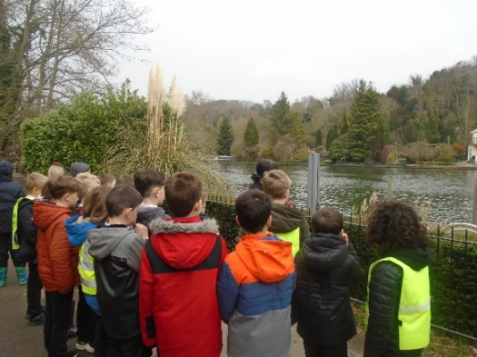
We finished our second class guided reading book, This Morning I Met a Whale by Michael Morpurgo. This led to some interesting discussions around pollution in the ocean and directly linked to our story and letter writing at the end of this term. We found out lots of facts about plastic pollution, which shocked us, and we used this to write persuasive letters to encourage others to ‘Reduce, Reuse, Recycle’ more. Perhaps you could see if you could reduce the amount of plastic you use this Easter?
In maths, we have focused on Multiplication and Division and Finding Area. The children have practised lots of formal written methods, as well as securing their understanding of what multiplication and division are. We continue to do lots of times tables practice and have now practised all tables up to 12 x 12. We are now combining tables to practise them in different combinations as well as continuing to use TT Rockstars daily in preparation for the Multiplication Check in June.
In science, we have made electrical circuits with bulbs and motors, looked at electrical safety as well as conductors and insulators. This circuit knowledge and understanding has been put to good use in our buggies recently! Later in the term, we looked at animals and their habitats, including food chains, classification keys and changes to animal’s habitats due to environmental changes.
Next term, we will be starting our final exciting topic, ‘Traders and Raiders’ looking at Saxons and Vikings. We will look at where they fit into the timeline following the Romans leaving Britain, their reasons for coming and their lifestyles and settlements. We also, of course, look forward to our camping trip to Rushall Farm, which will be many children’s first-time camping! It is always such fun and provides children with a little dose of independence and many happy memories. Altogether, we have another fun filled and busy term ahead with hopefully lots of sunshine and warm temperatures to come too. We wish a lovely Easter and a happy break.
We look forward to seeing you back in school in a few weeks,

Mrs Herring and Miss Stringer

