The Winchcombe Ten Core Walkthrus
Behaviour and Relationships
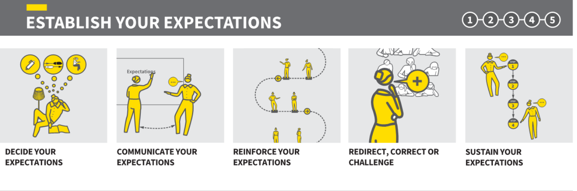
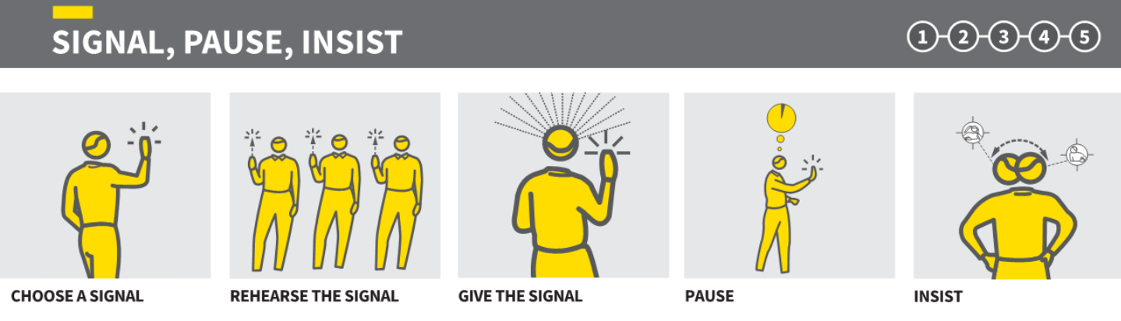
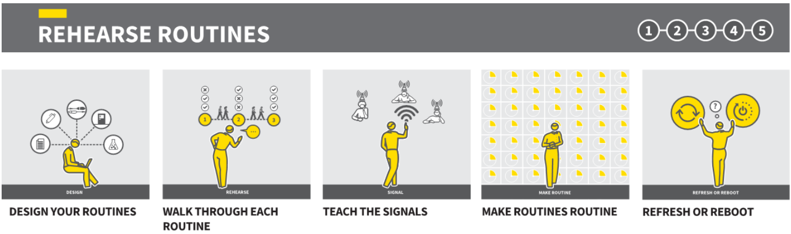
Explaining and Modelling
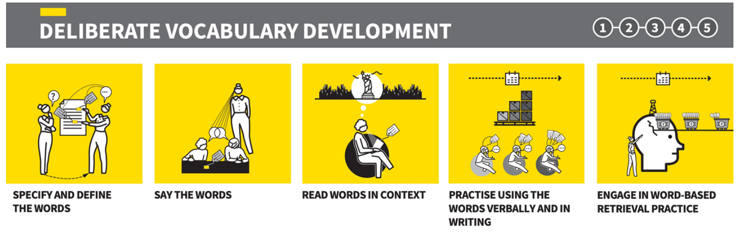
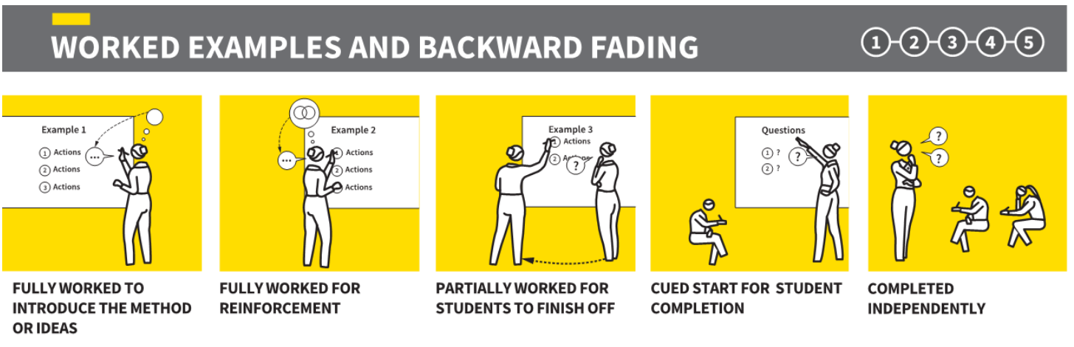

Questioning and Feedback
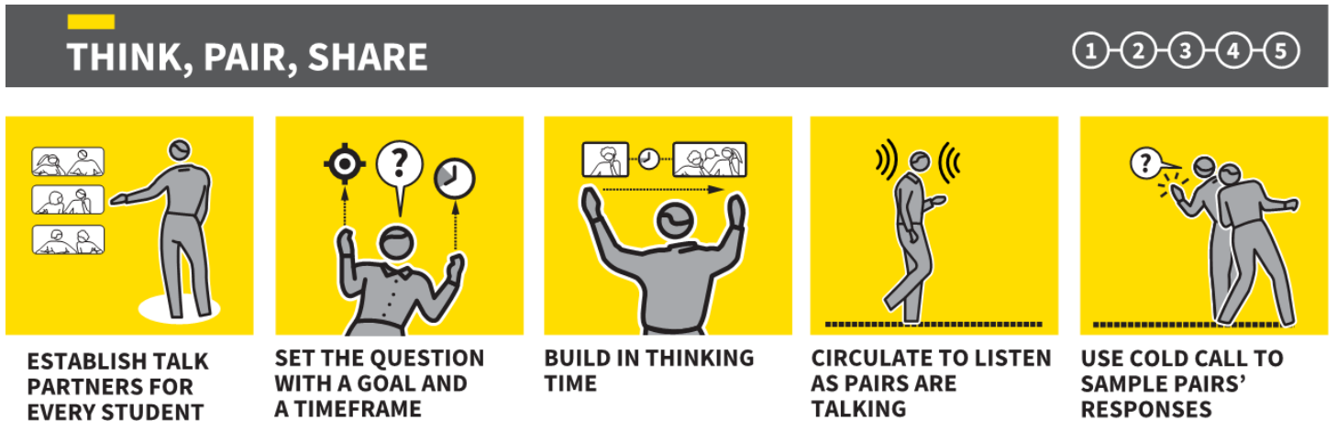
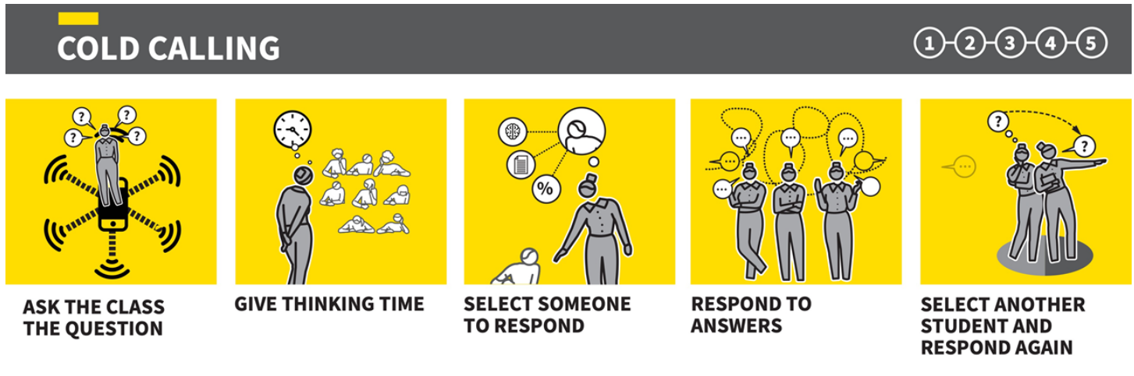
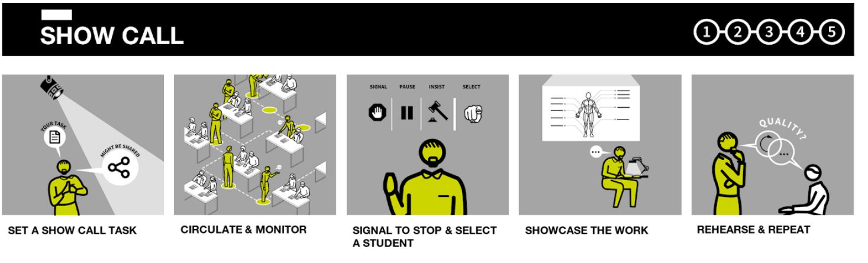
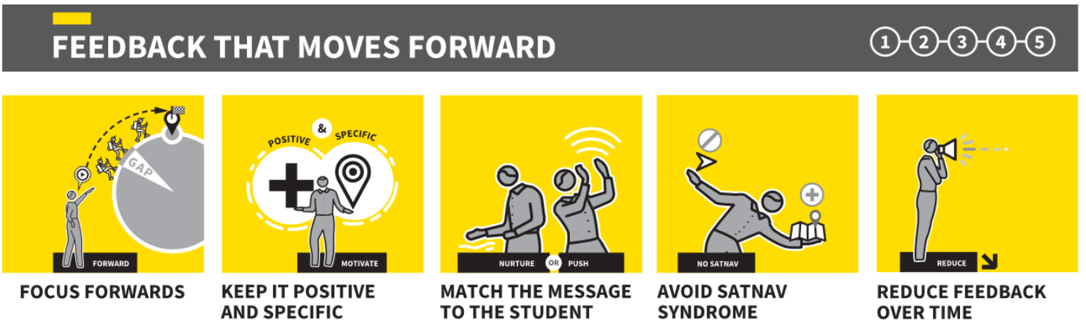

Practice and Retrieval


